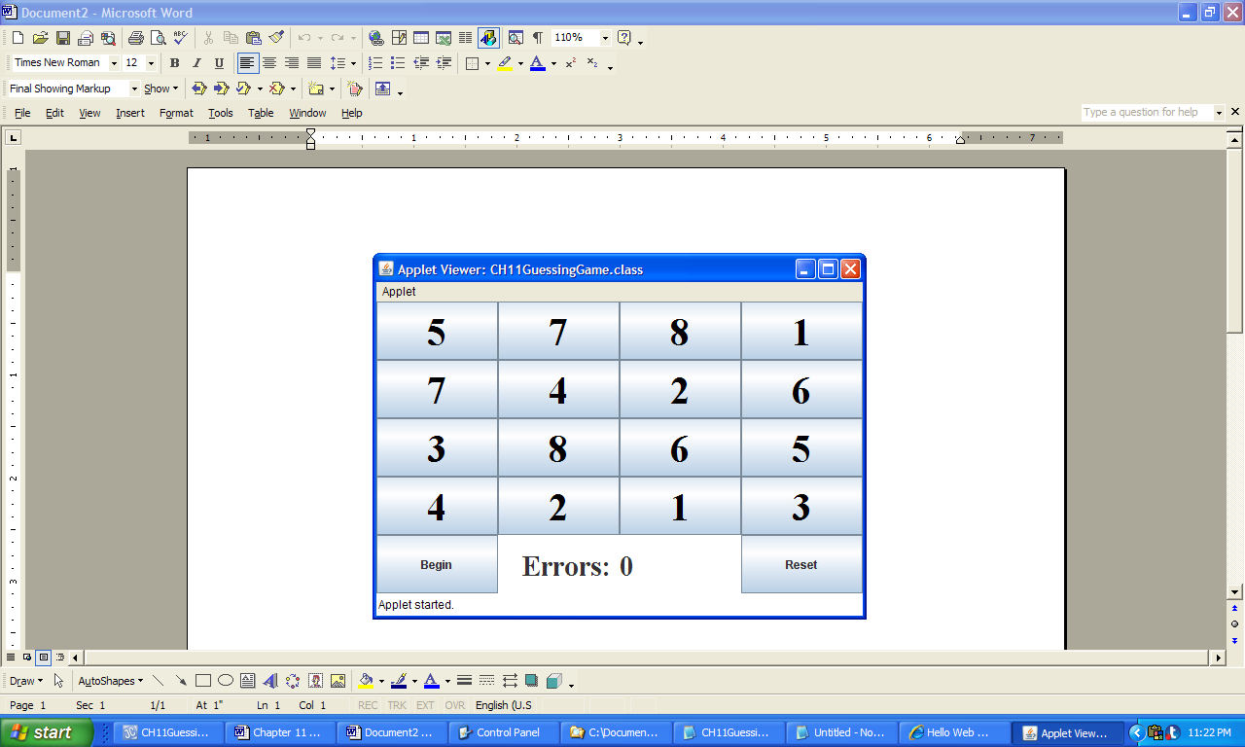

**Figure 11.48 The GUI produced by the applet GuessingGame.**